Anthony Cunningham

Research Data Management

Professor Eric Foster

2/13/2018

**Homework 2**

Problem 1

libname hw2 "H:\My SAS Files";

*Problem 1;

**data** hw2.allcausemortality;

infile "H:\Downloads\allcausemortality.csv" delimiter="," dsd;

input cause : $45. deaths2015 deaths1980 @@;

**run**;

**proc** **print** data=hw2.allcausemortality;

**run**;

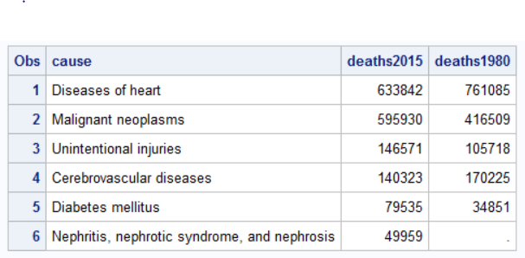

Problem 2

**data** increase;

set hw2.allcausemortality;

if deaths2015=**.** or deaths1980=**.** then increase="missing";

else if deaths2015 > deaths1980 then increase="1";

else increase="0";

**run**;

**proc** **print** data=increase;

**run**;

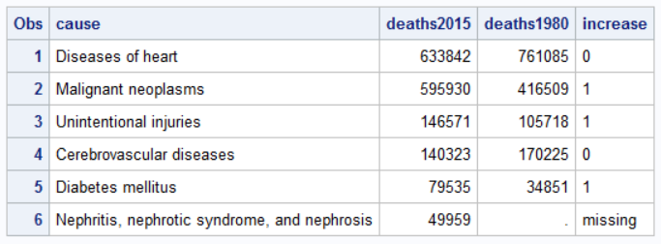

Problem 3

*Problem 3;

**data** mysummary;

set hw2.bloodsugar;

changeGluc = gluc6 - blglucose;

percentGluc = changeGluc/blglucose;

format percentGluc **4.2**;

maxGluc = max(gluc1, gluc2, gluc3, gluc4, gluc5, gluc6);

meanGluc = mean(gluc1, gluc2, gluc3, gluc4, gluc5, gluc6);

format meanGluc **6.2**;

attendance = **6** - nmiss(gluc1, gluc2, gluc3, gluc4, gluc5, gluc6);

keep subjectid changeGluc percentGluc maxGluc meanGluc attendance;

**run**;

**proc** **print** data=mysummary (obs=**10**);

**run**;

